Title: | X-Ray Fluorescence (XRF)
From: | Peter Morgan (RPS) | Date: | 28/11/19

What does the instrument measure?
The XRF analyser will quantify the elemental composition of a sample, so if you are interested in it take some time to revise some chemistry see the periodic table. Our analyser The Niton XL3T GOLDD can detect elements Mg to U.

Applications

The instrument is used in a range of industries:
- Scrap metal recycling
- Mining
- Precious metals
- Consumer goods

Applications in Geography and Environmental Science include:
- Characterising soils (Weindorf et al 2012)
- Investigating soil fertility (Sharma et al 2014)
- Elemental assessment of vegetation (McGladdery et al 2018)

How does the instrument work?

Take a look at this video for an explanation: https://www.youtube.com/watch?v=cAKcOyrt5Vc
If you prefer reading, see the Niton UK Guide to XRF technology.

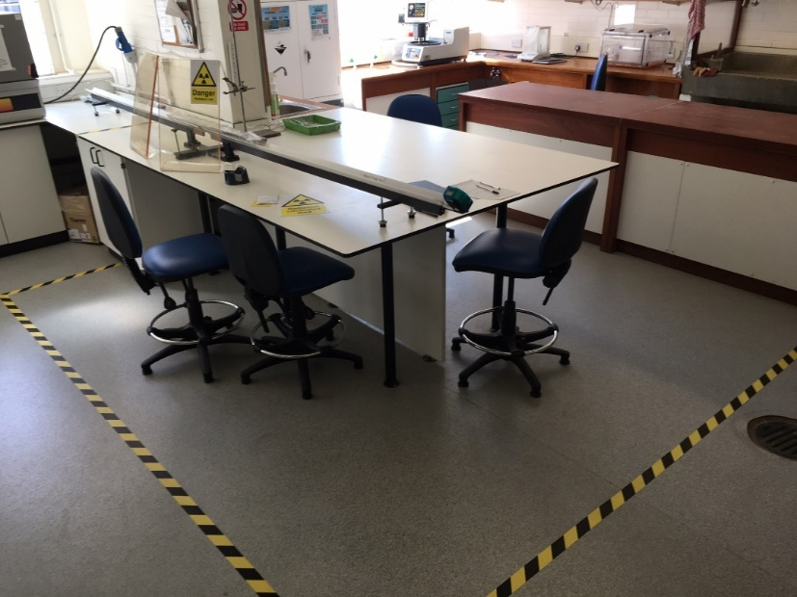
What are the safety considerations?
Because the instrument emits x-rays when analysing, there is a risk of ionising radiation. This has been investigated in a report on dose measurements taken by the RPS and RPA.
Given this risk assessment , therefore the instrument can only be used by authorised, trained personnel working in accordance with the local rules.
It is preferable that discrete sampling is used to allow the instrument to be used housed in its test stand. Non-authorised persons must stay out of the radiation controlled zone, demarcated in the lab by the yellow and black line.

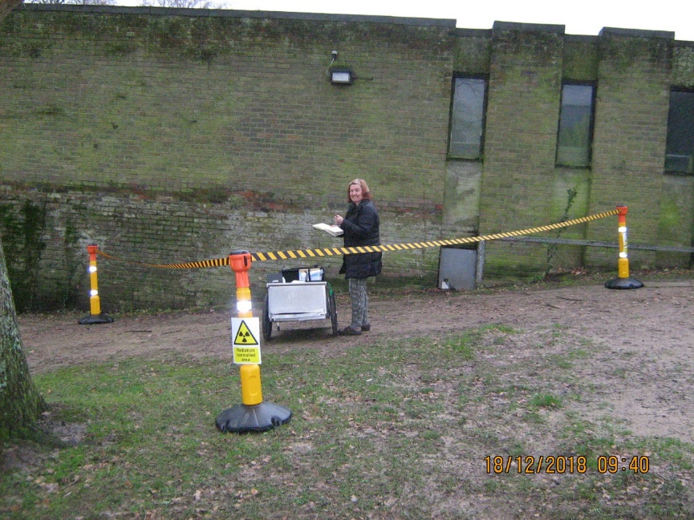
Working in the field the use of the test stand may not be practicable, for in situ sampling in handheld use, a Radiation Controlled Area must be setup, as shown in this example.

What is data is generated?

The instrument quantifies the amount of each element in a sample.

Therefore you could look at elements of interest for example here the Geothite limonite is a commercially exploited iron ore, so unsurprisingly has a high iron content, exploiting the other samples for iron mining would not be profitable!
The elemental composition can also be used to provenance samples, the higher calcium content of Soil C suggests its geological setting is more likely to be in Calcium Carbonate rocks such as chalk (a landscape found in the South Downs near Winchester).

Instrument set up
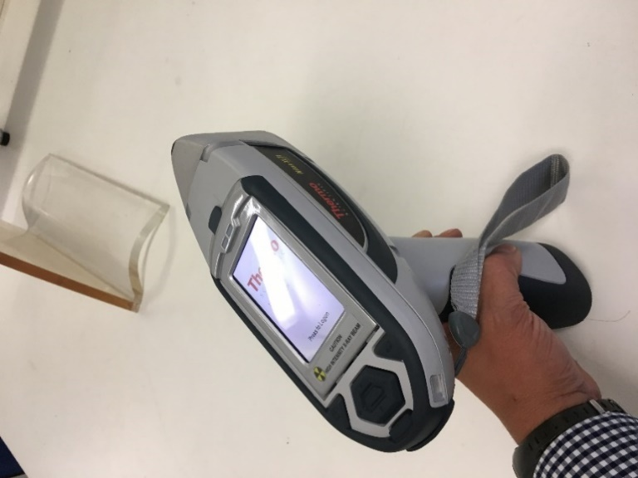
The instrument can report the elemental composition as a % of the total or in ppm (mg/kg). The amount of each element will be listed together with an error for that element reading. “Bal” refers to balance, the amount of signal the instrument is unable to attribute to an element (Bal + element readings=100%). It is desirable to get this as low as possible, increasing the duration of analysis is the best way to do this.
<LOD means less than limit of detection, Niton has figures on this sensitivity of the instrument, below the LOD an element is not detectable by the technology. Independent testing of these limits on topsoil samples has shown broad agreement with manufacturer published LODs (Shand and Wendler 2014)

The instrument can work in different modes these will allow you to focus on different ranges of elements. See example below:

Type | TestAll Geo | Soil | Mining
Duration | 155 | 155 | 155
Units | ppm | % | %
SAMPLE | c5 248-250 | c5 248-250 | c5 248-250
LOCATION | brd17 | brd17 | brd17
Bal | 962684.81 |  | 75.615
Bal Error | 148.38 |  | 0.128
Ca | 2047.27 |  | 0.201
Ca Error | 120.93 |  | 0.017
Mg |  |  | 0.347
Mg Error |  |  | 0.16
Al |  |  | 2.21
Al Error |  |  | 0.054
Si |  |  | 18.07
Si Error |  |  | 0.109
P |  |  | 0.031
P Error |  |  | 0.006
S | 107.81 |  | <LOD
S Error | 3.05 |  | 0.003
Cl |  |  | <LOD
Cl Error |  |  | 0.002
K | 10601.23 |  | 1.058
K Error | 170.45 |  | 0.025
Ti | 2759.81 |  | 0.273
Ti Error | 45.14 |  | 0.007
V | 46.68 |  | 0.004
V Error | 11.99 |  | 0.002
Cr | 58.49 |  | 0.006
Cr Error | 8.63 |  | 0.001
Mn | 652.76 | 0.067 | 0.072
Mn Error | 36.26 | 0.002 | 0.008
Fe | 20474.11 | 1.571 | 2.049
Fe Error | 157.38 | 0.007 | 0.024
Co | <LOD | <LOD | <LOD
Co Error | 61.5 | 0.004 | 0.01
Ni | 35.43 | 0.003 | <LOD
Ni Error | 11.97 | 0.001 | 0.004
Cu | 21.86 | 0.002
Cu Error | 7.09 | 0
Zn | 38.25 | 0.003
Zn Error | 4.61 | 0
As | 4.89 | 0 | <LOD
As Error | 2.08 | 0 | 0.002
Se | <LOD | 0 | <LOD
Se Error | 2.17 | 0 | 0.002
Rb | 48.29 | 0.004 | 0.005
Rb Error | 1.71 | 0 | 0.001
Sr | 41.77 | 0.004 | 0.004
Sr Error | 1.45 | 0 | 0.001
Zr | 222.99 | 0.022 | 0.021
Zr Error | 3.03 | 0 | 0.001
Nb | 7.76 |  | <LOD
Nb Error | 1.35 |  | 0.002
Mo | <LOD | <LOD | <LOD
Mo Error | 2.45 | 0 | 0.002
Pd | 0.94 |  | <LOD
Pd Error | 0.33 |  | 0.002
Ag | <LOD |  | <LOD
Ag Error | 0.27 |  | 0.002
Cd | 94824.45 |  | <LOD
Cd Error | 29.23 |  | 0.002
Sn | <LOD |  | <LOD
Sn Error | 0.56 |  | 0.002
Sb | <LOD |  | <LOD
Sb Error | 0.46 |  | 0.003
Ba | 313.06 |  | 0.028
Ba Error | 40.53 |  | 0.007
W | <LOD | <LOD | <LOD
W Error | 21.5 | 0.001 | 0.006
Au | <LOD | <LOD | <LOD
Au Error | 3.66 | 0 | 0.002
Pb | 12.33 | 0.001
Pb Error | 2.56 | 0
Bi | <LOD |  | <LOD
Bi Error | 3.81 |  | 0.002
Sc | 12322.31
Sc Error | 3.8
Te | <LOD
Te Error | 2.24
Cs | <LOD
Cs Error | 0.53
Hf | <LOD |  | <LOD
Hf Error | 1.5 |  | 0.004
Ta | <LOD |  | <LOD
Ta Error | 1.5 |  | 0.003
Re | <LOD |  | <LOD
Re Error | 1.5 |  | 0.003
Hg | <LOD | <LOD
Hg Error | 1.84 | 0
Th | 6.45 | 0.001
Th Error | 1.77 | 0
U | 6.6 | 0.001
U Error | 2.57 | 0

The instrument works at different energy ranges in order to analyse different elements, (Main, High, Low, Light) you can customise which are active and the time duration of these dependant on your results and available time. The main range detects most elements. Low and light ranges add the capability to analyse light elements (Al, Mg, Si, P, S) which cannot be efficiently excited in main range. High range optimises sensitivity for elements Pd through to Ba. In the element range menu, click on the ? to display the elements a particular range is designed to detect.

Sample Preparation

For discrete samples the sample cup should be full, this ensures at least 2g of sediment required for satisfactory results is present (Shand and Wendler 2014).
For the analysis of soils and sediments the moisture content can affect the accuracy of results, with the apparent concentrations decreasing with increased moisture. This can be a small error with low moisture content but will be a large error when soil/sediment is saturated. Therefore samples should be dried prior to analysis when moisture content exceeds 20% (Kalnicky and Singhvi 2001).
SAMPLE | Bal | Bal Error | Ca | Ca Error | Mg | Mg Error | Al | Al Error | Si | Si Error
Clay air dry | 66.472 | 0.123 | 0.071 | 0.009 | <LOD | 0.225 | 12.385 | 0.121 | 16.687 | 0.074
clay wet | 91.798 | 0.032 | 0.02 | 0.004 | 0.126 | 0.082 | 1.912 | 0.033 | 4.446 | 0.031

Data analysis

As you can see the XRF generates a lot of data relatively quickly. In addition to elements the XRF can calculate the proportions of several oxides including CaO and SiO.

How you analyse this data (Croudace et al 2006) will depend on your research question. It maybe you want to focus on the elements that are common in all your samples for a comparison, on the other hand it may be rarer elements that are of interest in fingerprinting sediment sources or processes.

In down core studies (Croudace and Rothwell 2015), you may wish to start by graphing the main elements to see how they vary by depth. Many researchers go on to study particular ratios of elements as proxies of environmental processes, for example grain size (Liu et al 2019).

References
Croudace, I. Rindby, A and Rothwell, G. (2006) ITRAX: Description and evaluation of a new multifunction X-ray core scanner. Geological Society of London Special Publications. V.267. P51-63

Croudace, I and Rothwell, G (2015) (eds) Micro XRF studies of sediment cores. Developments in Palaeoenvironmental Research 17

Kalnicky, D. J, and Singhvi, R. (2001). Field Portable XRF analysis of Environmental Samples. Journal of Hazardous Materials. 83. 93-122

Liu et al (20019). An empirical method to predict grain size from inorganic geochemical measurements. Geochemistry, Geophysics, Geosystems. 20

McGladdery, C. et al (2018). Elemental Assessment of Vegetation via portable x-ray fluorescence (PXRF) spectrometry. Journal of Environmental Management. 210. 210-225.

Sharma et al (2014). Characterising soils by X-ray fluorescence spectrometer 4: Cation Exchange Capacity (CEC). Geoderma. 239-240. 130-134.
Shand, C, and Wendler, R. (2014). Portable X-ray Fluorescence analysis of mineral and organic soils and the influence of organic matter. Journal of Geochemical Exploration. 143. 31-42.

Weindorf et al (2012). Characterising soils by X-ray fluorescence spectrometer 2: Spodic and Albic horizons. Geoderma. 189-190. 268-277

